**PROJECT REPORT TEMPLATE**

**1 INTRODUCTION**

**1.1 OVERVIEW**

Administrator should be able to create all base data including Semester , Candidate, Course and Lecturer ,Lecturer should have the ability to create Internal results, Dean ,who is one of the lecturer, should be the only one with ability to update Internal results, Re-evaluation can be initialized by candidate for all internal results. Now only Dean can update the marks after re-evaluation.

**1.2 PURPOSE**

A CRM system helps to keep candidate details up to date, track everycandidateinternal results, and manage it. It is designed to help improve candidate relationships.

**2 PROBLEM DEFINITION AND DESIGN THINKING**

**2.1 EMPATHY MAP**

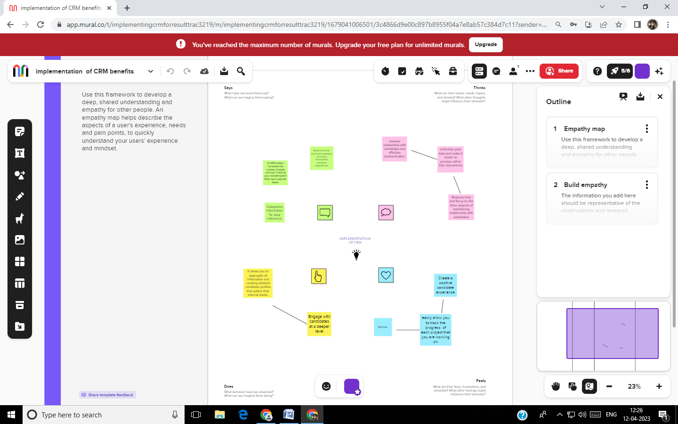

**2.2 IDEATION AND BRAINSTORMING MAP**

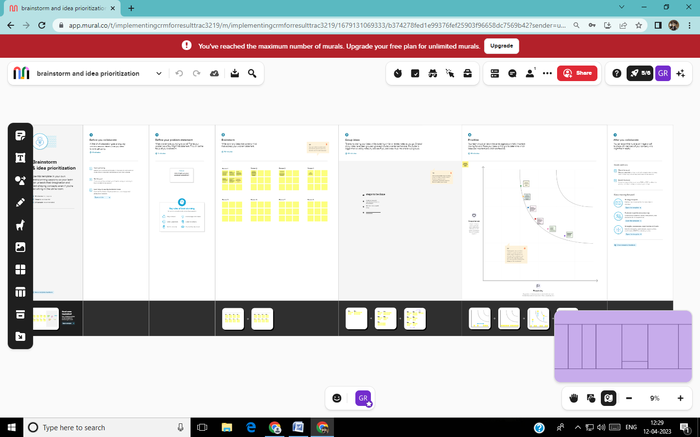

**3** **RESULT**

**3.1 Data Model:**

|  |  |
| --- | --- |
| **Object Name** | **Fields in the object** |
| Semester | |  |  | | --- | --- | | **Field** | **Data type** | | Semester Name | Text | | Course | Text | |
| Candidate | |  |  | | --- | --- | | Candidate Name | Text | | Candidate Id | Text | | Semester Name | Text | | Internal Results | Text | |
| Course Details | |  |  | | --- | --- | | Course Name | Text | | Course Id | Text | |
| Lecturer Details | |  |  | | --- | --- | | Lecturer Role | Text | | Lecturer Name | Text | | Course Id | Text | | Course | Text | |
| Internal Results | |  |  | | --- | --- | | Candidate Id | Text | | Course Id | Text | | Marks | Text | |

**3.2 ACTIVITY AND SCREENSHOT:**

**OBJECT:** Semester

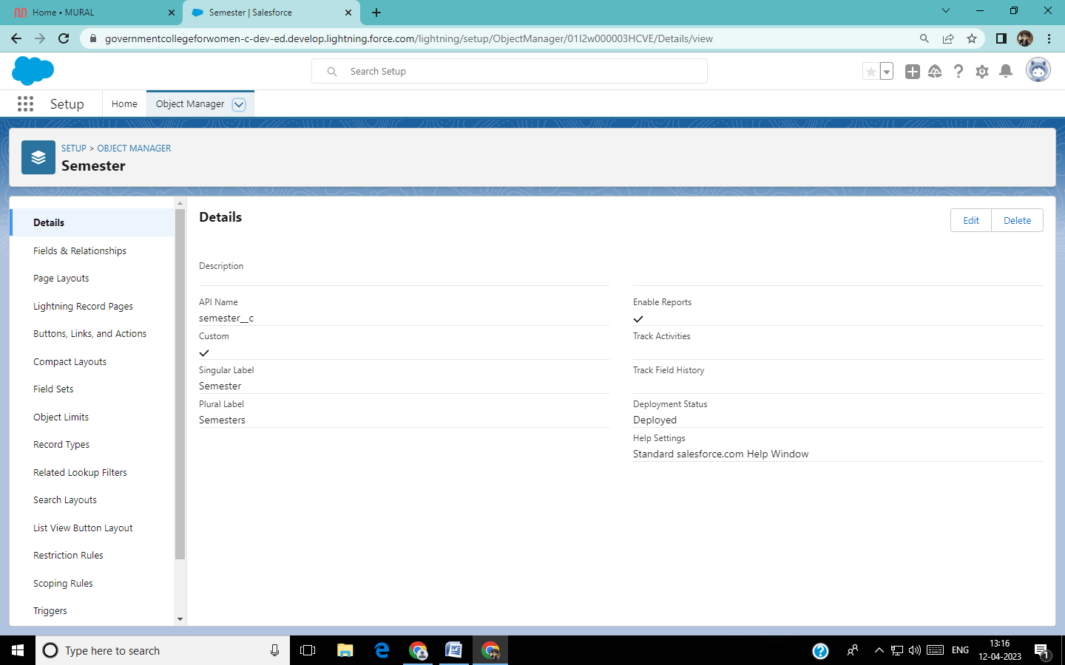

**OBJECT:** Course Details

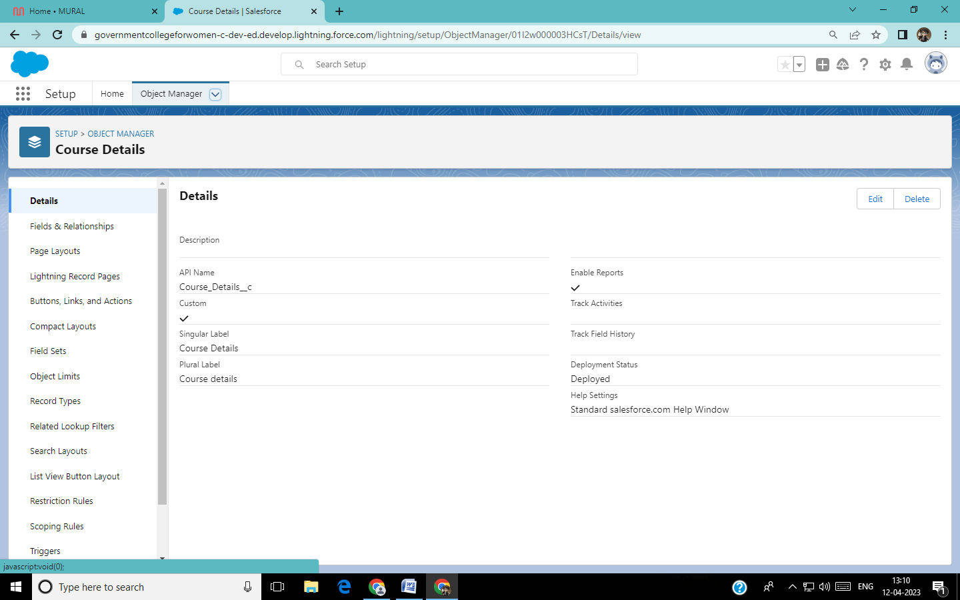

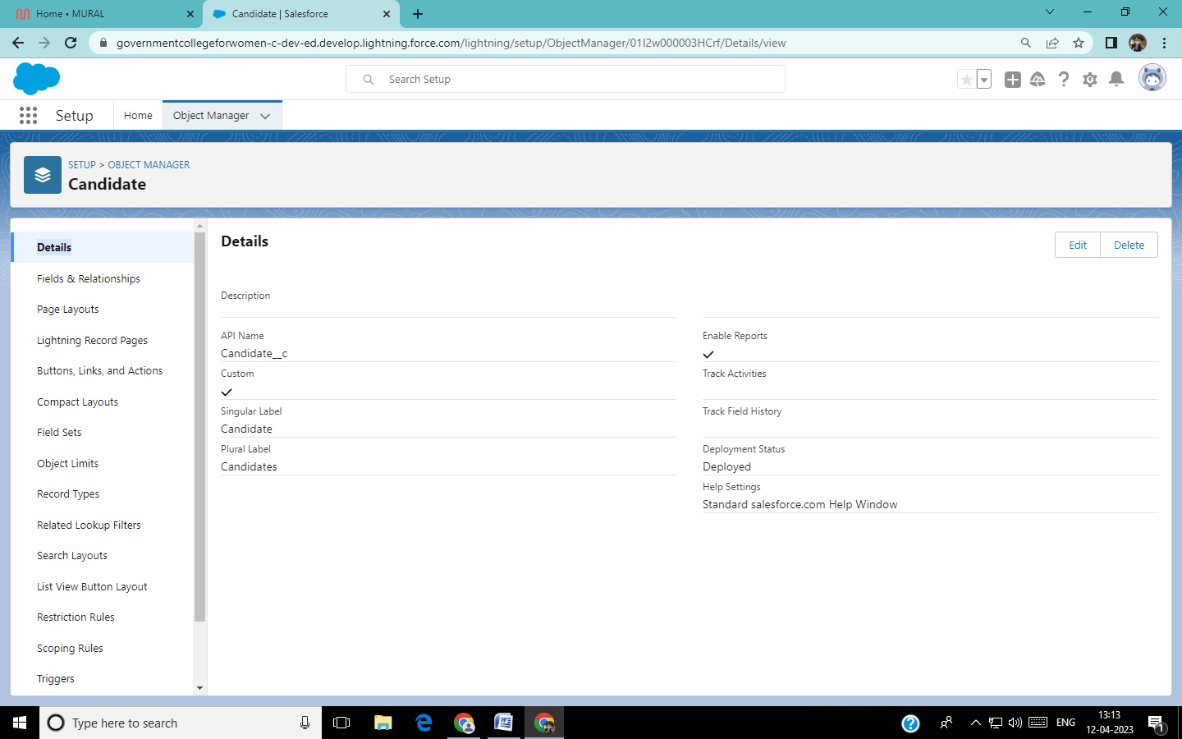 **OBJECT:** Candidate

**OBJECT:** Lecturer Details

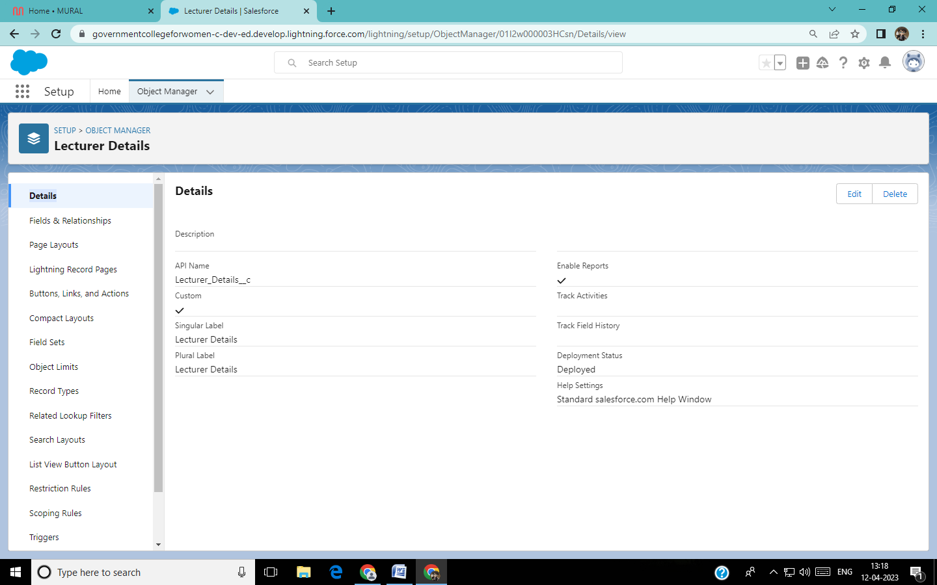

**OBJECT:** Internal Details

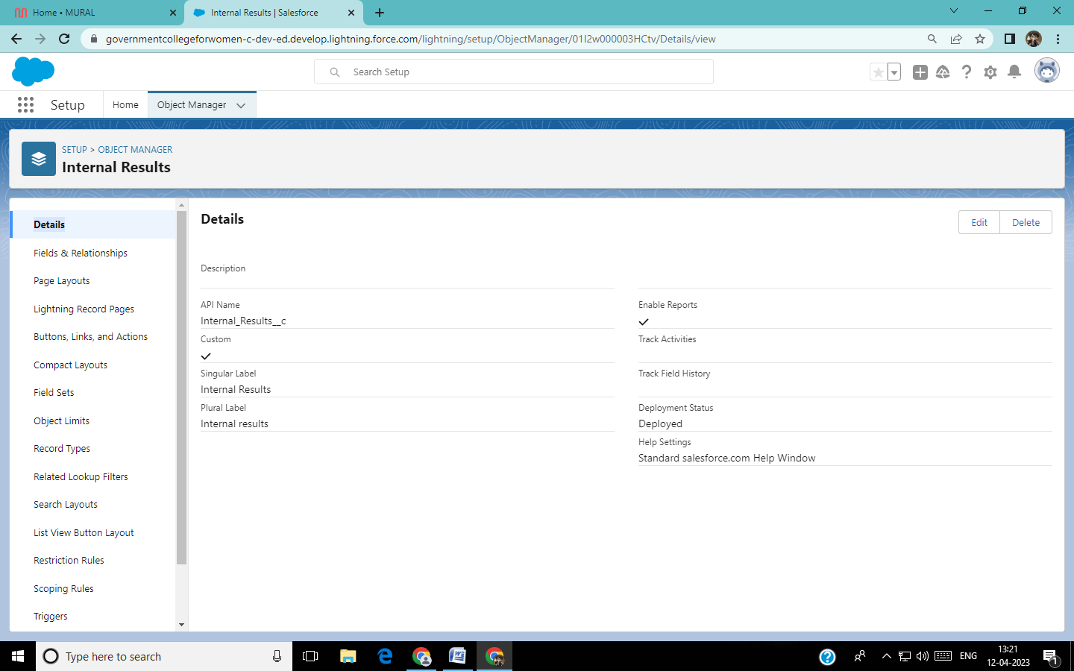

**LIGHTINING APP:**

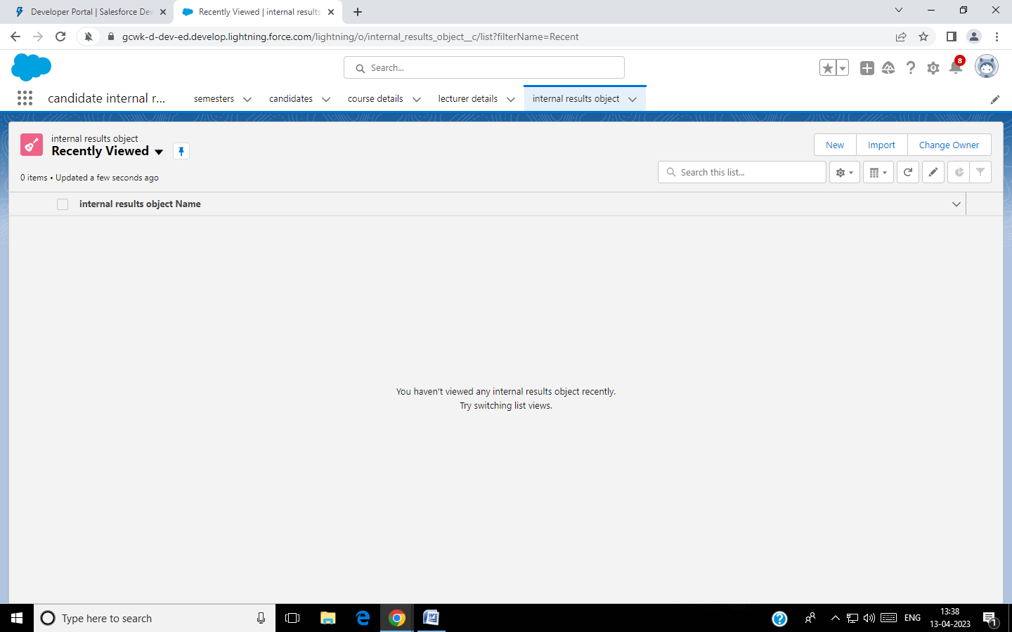

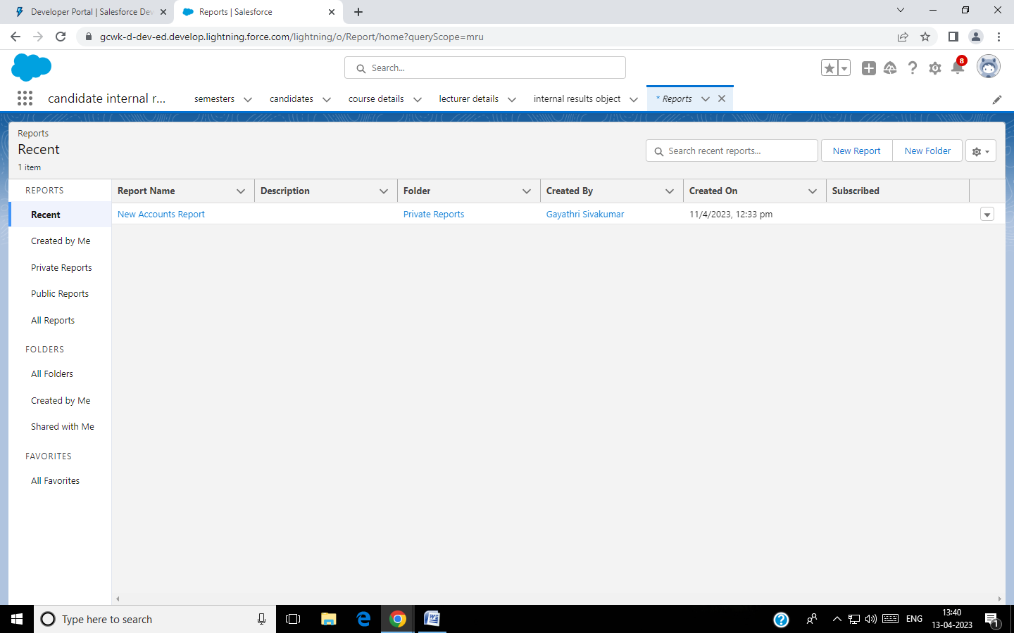**REPORTS:**

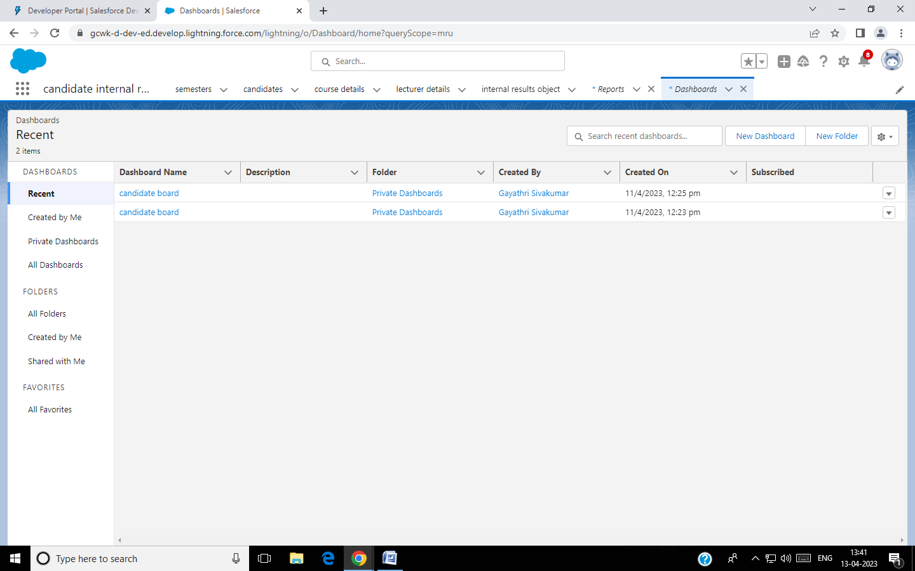**DASHBOARD:**

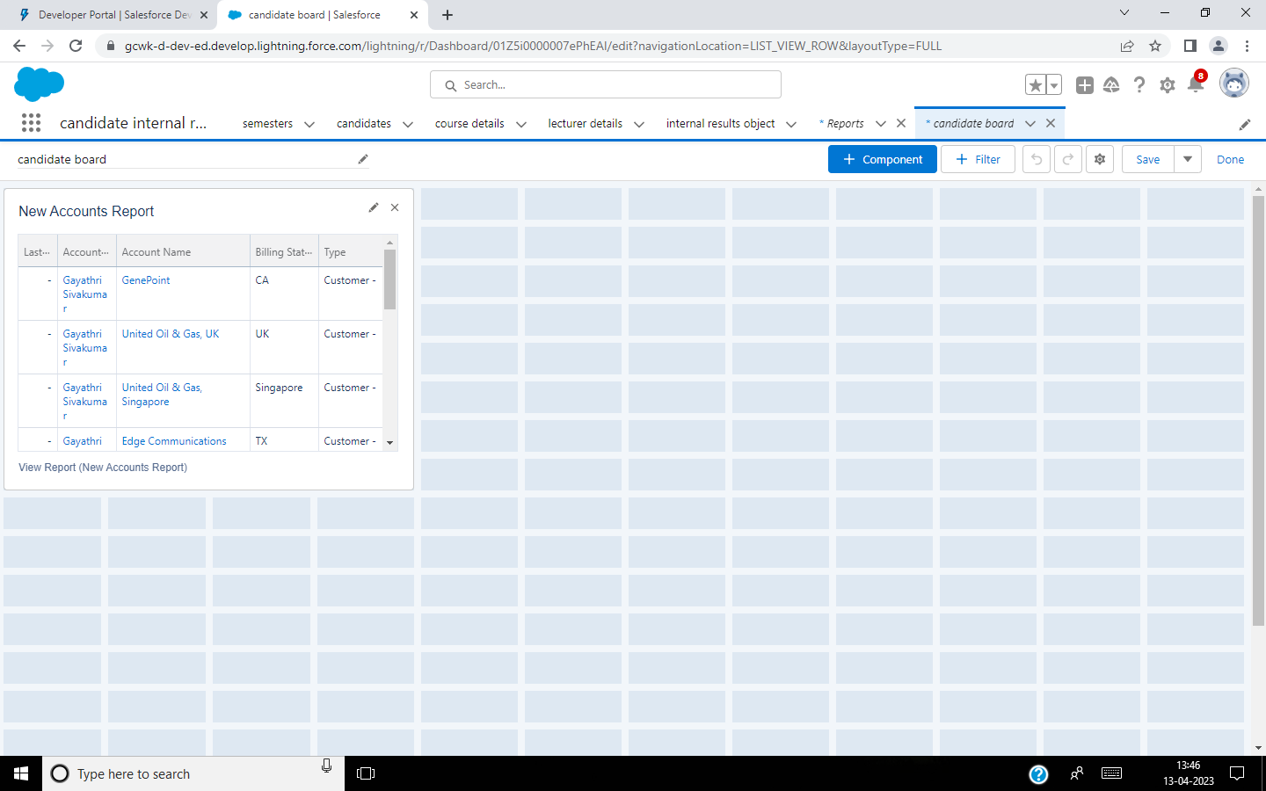

**4 TRAILHEAD PUBLIC PROFILE URL:**

|  |  |  |  |  |
| --- | --- | --- | --- | --- |
| |  | | --- | |  | | ) |  | https://mail.google.com/mail/u/0/images/cleardot.gif  https://mail.google.com/mail/u/0/images/cleardot.gif |
| |  | | --- | | https://mail.google.com/mail/u/0/images/cleardot.gif | | | |

**Team Member 1:** <https://trailblazer.me/id/gsubbaiyaa>

**Team Member 2:** <https://trailblazer.me/id/harim126>

**Team Member 3:** <https://trailblazer.me/id/inbam3>

**Team Member 4:** <https://trailblazer.me/id/gsivakumar21>

**PROJECT REPORT TEMPLATE:**

**5. ADVANTAGES:**

* Easy to get candidates internal marks.
* Easy to access and it is faster.
* Better understanding of the Candidates.

**DISADVANTAGES:**

* Improper knowledge about Salesforce leads to mistake.
* Salesforce app is slight expensive.

**6. APPLICATIONS**

This can be implemented in schools and colleges where the teachers or dean would easily get the candidates marks. This reduces the time in searching the results of a candidate.

**7. CONCLUSION:**

* Learned to use salesforce app.
* Learned to create object and fields.
* Learned to develop app in salesforce.
* Gained knowledge about Salesforce applications.

**8. FUTURE SCOPE:**

We expect Salesforce to integrate Data Science and big data capabilities to its Service cloud and Marketing cloud.